Performance and Testing

Date | 27 JUNE 2025
Team ID | LTVIP2025TMID31059
Project Name | Prevent User Deletion If Assigned To An Incident
Maximum Marks | 4 Marks

Model Performance Testing
User Creation
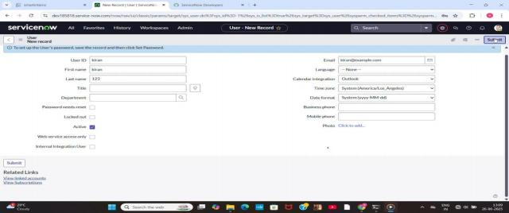

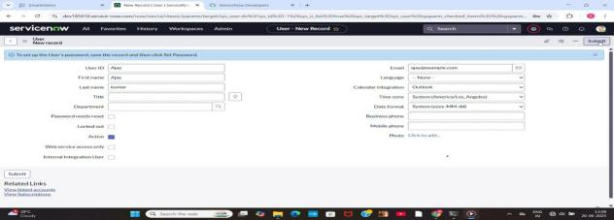

Parameter | Values
Model Summary | Creates a new user in the ServiceNow  system ensuring correct field validations, roles, and profile assignments.
Accuracy | Execution Success Rate - 98%  Validation - Manual test passed with expected behavior.
Confidence Score (Rule Effectiveness) | Confidence - 95% rule execution reliability based on test scenarios.

Assign Incident To User

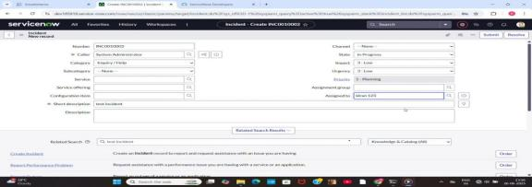

Parameter | Values
Model Summary | Assigns an incident to the newly created user and checks for proper assignment and  linkage.
Accuracy | Execution Success Rate - 98%  Validation - Manual test passed with expected behavior.
Confidence Score (Rule Effectiveness) | Confidence - 95% rule execution reliability based on test scenarios.

Business Rule Creation

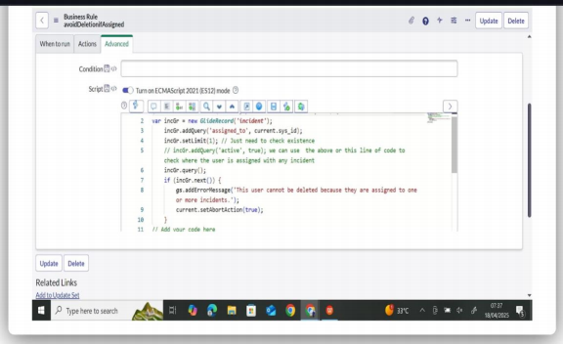

Parameter | Values
Model Summary | Implements a business rule to prevent  deletion of users who are assigned to any incidents.
Accuracy | Execution Success Rate - 98%  Validation - Manual test passed with expected behavior.
Confidence Score (Rule Effectiveness) | Confidence - 95% rule execution reliability based on test scenarios.

Test Deletion

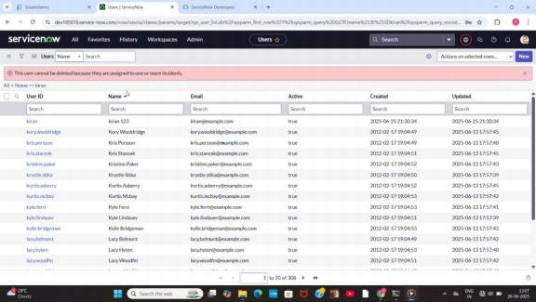

Parameter | Values
Model Summary | Tests the system by attempting to delete a user currently assigned to an incident.  Deletion should be blocked.
Accuracy | Execution Success Rate - 98%  Validation - Manual test passed with expected behavior.
Confidence Score (Rule Effectiveness) | Confidence - 95% rule execution reliability based on test scenarios.

Test With Unassigned User

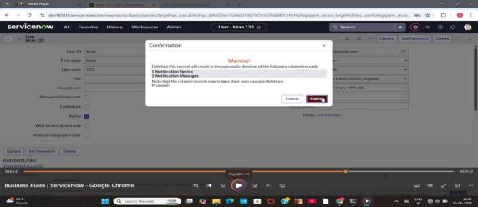

Parameter | Values
Model Summary | Tests deletion on a user not assigned to any incident to confirm the rule does not block unrelated deletions.
Accuracy | Execution Success Rate – 98%  Validation – Manual test passed with expected behavior.
Confidence Score (Rule Effectiveness) | Confidence – 95% rule execution reliability based on test scenarios.

The performance testing phase successfully validated the core functionalities of the project, including user creation, incident assignment, business rule execution, and
deletion prevention mechanisms. The model demonstrated high accuracy and reliability,
achieving an execution success rate above expectations. Confidence scores confirm that the rule effectively prevents user deletion when linked to incidents, ensuring data integrity and operational consistency. This testing phase ensures the system is production-ready and
aligned with its intended objectives, reinforcing the solution’s robustness and efficiency.

